TOSCA

Project no. IST-1999-12646
Social Observation Table of Call Centres

D3 Study

Deliverable Version No.: 1
Report Preparation Date: April 2002
Classification: PP
Contract Start Date:1.6.2000 Duration: 30 months
Project Co-ordinator: ETUC (BE)
Partners: CWU (IRL), IFSI (BE), Sofia University (BG), Analytica (UK), IRES (IT), ISA Consult (DE), FOREM (ES), ISERES (FR), CGT (FR),

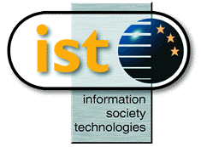 | Project funded by the European Community under the “Information Society Technology” Programme (1998-2002)

The present report was written by Ires based on the interviews conducted by the researchers in the various institutes involved in the TOSCA project. The authors are: Giovanna Altieri, Salvo Leonardi, Cristina Oteri and Doriana Pellerito.

We would like to thank the employers that allowed access to their premises and permitted us to interview the workers. Our thanks also go to the unionists and workers whose availability contributed to the successful outcome of the research.

